MCCE Funding Priorities & Process

*Notes from the January 18, 2018, MD Computing Education Steering Committee Meeting*

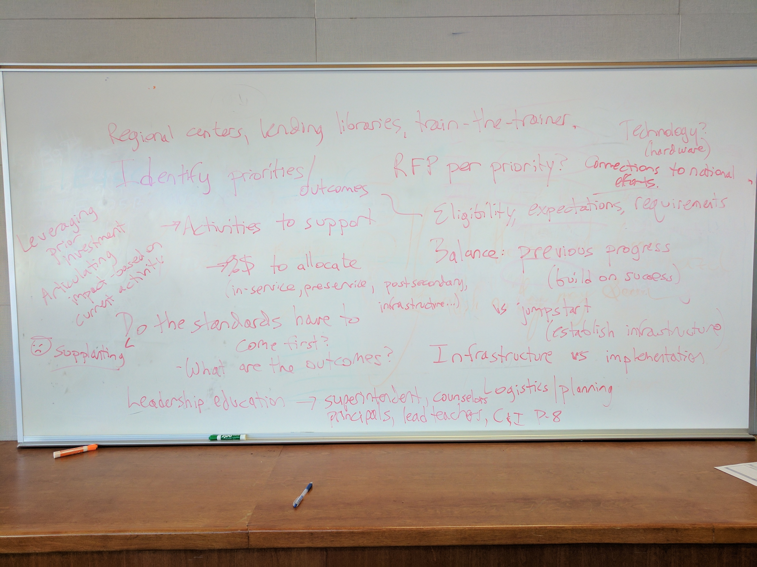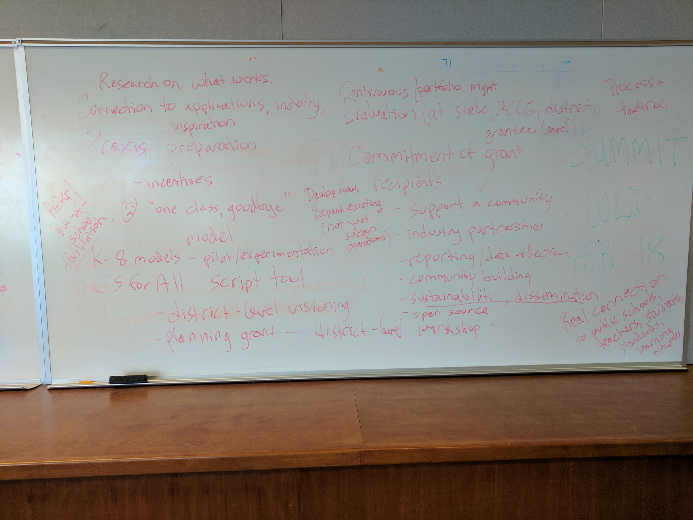

Priorities and Outcomes

* One proposed approach: start with set of activities to support (in-service, preservice, postsecondary, infrastructure…)
* What are the (intended) outcomes?
  + Determine what amount of money to allocate
  + Should we issue a separate RFP for each priority?
* Eligibility, expectations, requirements
* Draw connections to national efforts
* Balance previous progress (build on success) vs. jumpstart (establish infrastructure)
  + Leveraging prior investment
  + Articulating impact – based on current activity
  + NOT supplanting existing planned/ongoing efforts
* Infrastructure vs. implementation
* Logistics/planning funding

Other possible activities that could be funded/supported:

* Regional centers, lending libraries, train-the-trainer
* Technology (hardware)
* Leadership education: superintendents, counselors, principals, lead teachers, C&I(?) P-8
* After/out-of-school facilitation
* Praxis preparation
* Incentives to prepare for and take the exam
* Avoid “one class, goodbye” structure

General questions:

* Do the standards have to come first?

Things to consider:

* Research on what works
* Connection to applications, industry, inspiration
* K-8 models: pilot/experimentation
* CS for All script tool (Code.org)
* District-level visioning
* Planning grant at the district level

Commitment that grant recipients should be expected to make:

* Support a community
* Develop new activities, expanding existing ones (don’t just sustain operations)
* Industry partnerships
* Reporting/data collection
* Community building
* Sustainability, dissemination
* Open source
* Real connection to public schools, teachers, students, standards, learning outcomes

Commitment of MCCE

* Process & timeline – develop now, possibly start soliciting proposals now (or at least after budget is approved by mid-April), hit the ground running when the funding arrives on July 1
* Continuous/portfolio management of overall set of activities
* Evaluation (at state, MCCE, district, grantee level)