MARYLAND’S PROJECT LEAD THE WAY
COUNSELORS’ CONFERENCE

October 31, 2017
DRAFT Conference Agenda

What | When
Registration and Continental Breakfast | 8:00 – 8:30 AM
Welcome | 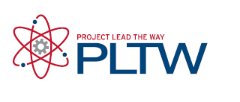  8:30 – 9:00 AM
Maryland’s System of Career and Technology Education | 9:00 – 9:30 AM
Keynote Presentation - Dr. Tuajuanda Jordan, President, St. Mary’s College of Maryland | 9:30 – 10:00 AM
Break | 10:00 - 10:15 AM
Breakout Session I:  - Student Presentations (Biomedical and Engineering)  - PLTW 101  - CTE Principal/Counselor Panel  - Equitable Recruitment Practices in CTE  - Neurodiversity and the Workplace | 10:15 - 11:15 AM
Breakout Session II:  - Student Presentations  - STEM Employer Panel  - Computer Science Program of Study  - PLTW Launch and Gateway Programs  - Worcester County: Increasing Counselor Knowledge of CTE  - Maryland’s Information Technology Career Cluster | 11:20 – 12:20 PM
Lunch | 12:30 - 1:15 PM
Breakout Session III:  - STEM Employer Panel  - College Student Panel  - Neurodiversity and the Workplace  - Maryland’s CTE Social Media Campaign | 1:30 - 3:00 PM

